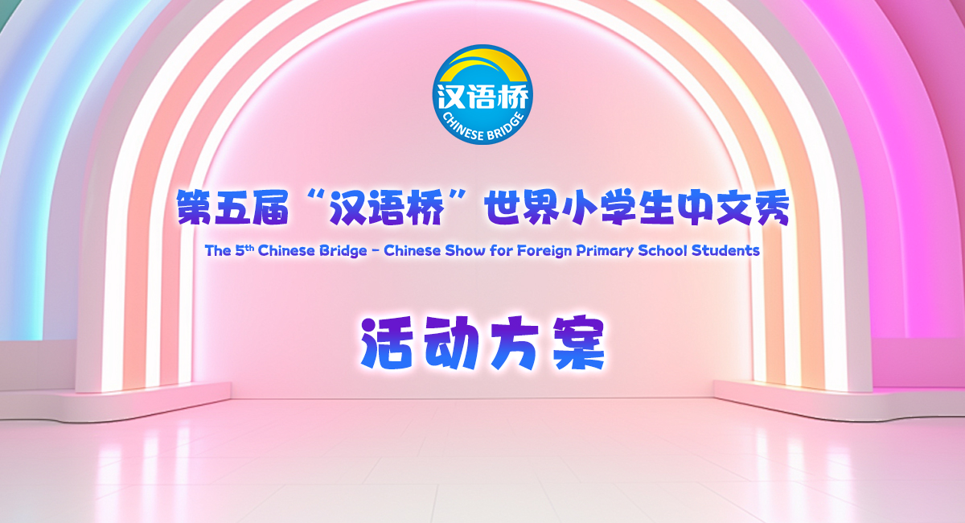

The 5th “Chinese Bridge”
- Chinese Proficiency Competition for
Foreign Primary School Students
The South Island Regional Competition 2025

The "Chinese Bridge" Chinese Proficiency Competition aims to encourage students in learning Chinese and deepen their understanding of Chinese language and culture.
Categories:
- Primary Category （age 6-12, born on or after September 1, 2012, are eligible to participate.）
Eligibility of Participants:
In accordance with the Centre for Language Education and Cooperation (CLEC) regulations, students representing New Zealand in the International Competition in China must meet the following criteria:
i. Be a New Zealand citizen or New Zealand permanent resident (non-Chinese citizenship);
ii. Have been brought up in countries and regions outside of China;
iii. Do not have Chinese as their first language. Neither parent can be native speakers of Chinese;
iv. Be a full-time student enrolled at a school in the South Island, New Zealand;
v. In principle, participants in the previous global finals are not allowed to participate in the same competition for two consecutive sessions.

For any questions regarding eligibility, they should be addressed to the organising committee (For more information about how to do this, please contact Xiaolu Chen xiaolu.chen@canterbury.ac.nz). The organising committee will decide based on the available information. The committee’s decision is final. Should any candidate be found ineligible during the competition, they will be disqualified.
Registration Deadline for Regional Competition: (1st May 2025)
- Submit Letter of Authorisation (Attachment 1) and Letter of Consent (Attachment 2) to Xiaolu Chen(xiaolu.chen@canterbury.ac.nz) by 1st May 2025
Topic:
快乐中文 (Chinese, Joy & Fun)
Time and Venues for Regional Competitions:

 | Time and date | Venue | City
South Island Final | 13.30-17.30  Sunday 25th May | University of Canterbury  (Lecture Theatre) | Christchurch
Format of the Competition:
- Primary Category
The Competition consists of two sections: Chinese Speech and Talent Presentation. Contestants are encouraged to wear traditional Chinese costumes, or their own traditional dresses if desired. Students are asked not to wear their school uniforms.

- Chinese Speech: Each student is required to give a speech for no less than 2 minutes and no more than 3 minutes. Students are encouraged to use props or other forms of demonstration to enrich their presentations. It is not recommended that students simply read from a prewritten script. Their speeches will be judged according to the content, presentation, pronunciation and grammar. This section makes up 90% of the total score.
- Talent presentation: This is also part of the final competition. Each student is required to choose one performance art such as singing Chinese songs, playing an instrument, dancing, acrobatics, calligraphy, painting, paper-cutting, martial arts, etc. The presentation should last for no more than 3 minutes. The judges will evaluate each student's performance by its artistry and appeal. This makes up 10% of the total score.

Judging Criteria for the Junior Category
Sections | 1) Chinese Speech |  |  |  | 2) Talent | Total
Judging Criteria | Content  30% | Presentation  20% | Pronunciation  20% | Vocabulary and Grammar  20% | Artistry /  Appeal /  Complexity  10% | Language Part+  Talent
Percentage | 90% (Language Part) |  |  |  | 10% | 100%
Ranking Priority | 2 |  |  |  | 3 | 1

In 2025, A single South Island competition will be held in Christchurch, with no regional preliminary rounds.
School Representatives for the South Island Competition:
Schools or institutions are responsible for conducting their own selection process before the competition in Christchurch. CIUC encourages integrating competition activities into classroom learning. Each school may nominate up to five representatives in the Primary Category.
Prizes for South Island Competition:
Prizes and certificates will be issued according to each student’s ranking in the competition.
After the competition, following qualification verification by the Chinese Bridge New Zealand South Island Organizing Committee, one contestant will be recommended to travel to China, to represent New Zealand in the Chinese Bridge Chinese Proficiency International Competition later this year (event location and time to be confirmed). The selected contestant will receive official written notification following the South Island competition. All expenses for the selected contestant’s travel to China will be covered by the organizing committee of the global competition. A contestant under the age of 18 may be accompanied by one authorized guardian (teacher or parent) who will assume guardianship responsibilities and share accommodations with the contestant. Proper authorization needs to be arranged through their schools prior to the travel.
For further inquiries, please contact Xiaolu Chen from CIUC at xiaolu.chen@canterbury.ac.nz
More information about the “Chinese Bridge” Competition is available at http://bridge.chinese.cn.
--------------------------------------------------------------------------------------------------------------------------------------
Attachment 1:
Attachment 2:

