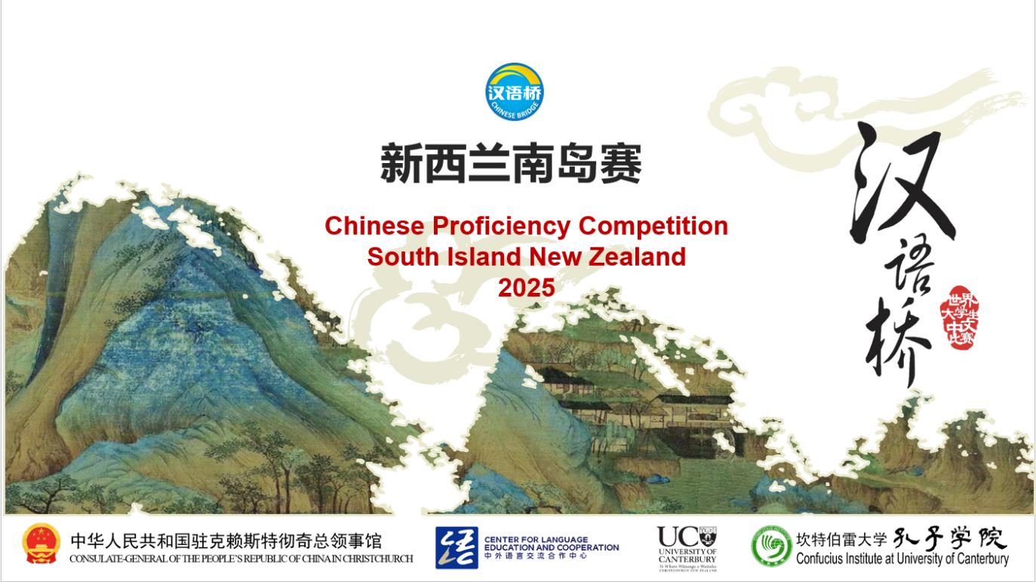

**The 18th “Chinese Bridge” - Chinese Proficiency Competition**

**for Foreign Secondary School Students**

**The South Island Regional 2025**

The "Chinese Bridge" Chinese Proficiency Competition aims to encourage students in learning Chinese and deepen their understanding of Chinese language and culture.

**Categories:**

* Secondary Category (Junior: Year 9-10)
* Secondary Category (Senior: Year 11-13)

(age 12-18, born between September 1, 2006, and August 31, 2012, are eligible to participate.)

**Eligibility of Participants:**

According to regulations set by the Centre for Language Education and Cooperation (CLEC), students representing New Zealand in the International Competition in China must meet the following criteria:

i. Be a New Zealand citizen or New Zealand permanent resident (non-Chinese citizenship).

ii. Have been raised in countries or regions outside of China.

iii. Do not have Chinese as their first language, with neither parent being a native Chinese speaker.

iv. Be full-time students enrolled at a school in the South Island, New Zealand.

In principle, participants from the previous global finals are not allowed to participate in the same category of competition for two consecutive years.

For any questions regarding eligibility, they should be addressed to the organising committee (For more information about how to do this, please contact Xiaolu Chen [xiaolu.chen@canterbury.ac.nz](mailto:xiaolu.chen@canterbury.ac.nz)). The organising committee will decide based on the available information. The committee’s decision is final. Should any candidate be found ineligible during the competition, they will be disqualified.

**Registration Deadline for Regional Competition: (1st May 2025)**

1. Submit Letter of Authorisation (Attachment 1) and Letter of Consent ([Attachment 2](Attachment%202（Letter%20of%20consent）.docx)) to Xiaolu Chen([xiaolu.chen@canterbury.ac.nz](mailto:xiaolu.chen@canterbury.ac.nz)) by 1st May 2025

**Topic:**

**追梦中文，不负韶华** (Fly high with Chinese)

**Time and Venues for Regional Competitions:**

|  |  |  |  |
| --- | --- | --- | --- |
|  | Time and date | Venue | City |
| South Island Final | 13.30-17.30  Sunday 25th May | University of Canterbury (Lecture Theatre) | Christchurch |

**Format of the Competition:**

* **Secondary Category (Junior: Year 9-10)**

Chinese speech (2 - 3 minutes) + Talent presentation (up to 3 minutes)

* **Secondary Category (Senior: Year 11-13)**

Chinese speech (2 - 3 minutes) + Q&A session + Talent presentation (up to 3 minutes)

**Secondary Category (Junior: Year 9-10)**

The Competition consists of two sections: Chinese Speech and Talent Presentation. Contestants are encouraged to wear traditional Chinese costumes, or their own Chinese traditional dresses if desired. Students are asked to **not** wear their school uniforms.

1. **Chinese Speech**: Each student is required to give a speech for no less than 2 minutes and no more than 3 minutes. Students are encouraged to use props or other forms of demonstration to enrich their presentations. Students should not simply read from a pre-written script. Their speeches will be judged according to the content, presentation, pronunciation and grammar. This section makes up 90% of the total score.
2. **Talent presentation:** This is also part of the final competition. Each student is required to choose one performance art such as singing Chinese songs, playing an instrument, dancing, acrobatics, calligraphy, painting, paper-cutting, martial arts, etc. The presentation should last for no more than 3 minutes. The judges will evaluate each student's performance by its artistry and appeal. This makes up 10% of the total score.

|  |  |  |  |  |  |  |
| --- | --- | --- | --- | --- | --- | --- |
| **Judging Criteria for the Junior Category** | | | | | | |
| **Sections** | **1) Chinese Speech** | | | | **2) Talent** | **Total** |
| **Judging Criteria** | Content  30% | Presentation  20% | Pronunciation  20% | Vocabulary and Grammar  20% | Artistry /  Appeal /  Complexity  10% | Language Part+  Talent |
| **Percentage** | 90% (Language Part) | | | | 10% | 100% |
| **Ranking Priority** | 2 | | | | 3 | 1 |

**Secondary Category (Senior: Year 11-13)**

The Competition consists of three sections: Chinese Language Speech, Question and Answer session and a Talent Presentation. Contestants are encouraged to wear traditional Chinese costumes, or their own traditional dresses if desired. Students are asked to **not** wear their school uniforms.

1. **Chinese Speech:**  For this section, each student is required to give a speech for no less than 2 minutes and no more than 3 minutes. Students are encouraged to use props or other forms of demonstration to enrich their presentations. Students should not simply read from a pre-written script. Their speeches will be judged according to the content of the speech, presentation, pronunciation, vocabulary and grammar. This section makes up 70% of the total score.
2. **Q & A :** Immediately after the speech, the student will select a pre-prepared question from a pool ([Attachment 3](Attachment%203（Questions%20List%20for%20Secondary(Senior)%20Category）.docx)) and answer it in Chinese. One of the judges will then ask for more details from the contestants, which should be answered in Chinese. The question list will be provided to all contestants in advance. This makes up 20% of the total score.
3. **Talent Presentation:** Each student is required to choose one performance art such as singing Chinese songs, playing an instrument, dancing, acrobatics, calligraphy, painting, paper-cutting, martial arts, etc. The presentation should last for no more than 3 minutes. This makes up 10% of the total score.

|  |  |  |  |  |  |  |  |
| --- | --- | --- | --- | --- | --- | --- | --- |
| **Judging Criteria for the Senior Category** | | | | | | | |
| **Sections** | **1) Chinese Speech** | | | | **2) Q&A** | **3) Talent** | **Total** |
| **Judging Criteria** | Content  20% | Delivery  20% | Pronunciation  20% | Vocabulary and Grammar  10% | Accuracy / Completeness /Reaction  Speed  20% | Artistry /  Appeal /  Complexity  10% | Language Part+  Talent |
| **Percentage** | 90% (Language Part) | | | | | 10% | 100% |
| **Ranking Priority** | 2 | | | | | 3 | 1 |

In 2025, there will only be one South Island competition taking place in Christchurch at the University of Canterbury with no regional competitions.

**School Representatives for the South Island Competition:**

A **single** South Island competition will be held in **Christchurch**, with no regional preliminary rounds.

Schools or institutions are responsible for conducting their **own selection process** before the competition. CIUC encourages integrating competition activities into classroom learning so that all students are given equal opportunities. Each school may nominate up to six representatives for the Senior and Junior groups of the Secondary Student Category, respectively.

**Prizes for South Island Competition:**

* Prizes and certificates will be issued according to each student’s placing in the competition.
* Following the competition and qualification verification by the Chinese Bridge New Zealand South Island Organizing Committee, one contestant will be selected to represent New Zealand at the Chinese Bridge Chinese Proficiency International Competition in China later this year. All expenses for traveling to China will be covered (event days and locations to be confirmed). The selected contestant will receive official written notification after the conclusion of the South Island Competition.
* Contestants under the age of 18 may be accompanied by one authorized guardian to China, who will assume guardianship responsibilities and share accommodations with the contestant. Proper authorization needs to be arranged through their schools prior to the travel.

For further inquiries, please contact Xiaolu Chen from CIUC at [xiaolu.chen@canterbury.ac.nz](mailto:xiaolu.chen@canterbury.ac.nz)

More information about the “Chinese Bridge” Competition is available at <http://bridge.chinese.cn>.

--------------------------------------------------------------------------------------------------------------------------------------

Attachment 1: 

Attachment 2: 

Attachment 3: 