EPA TRACKED CHEMICALS CHECK

Tracking regulations for each chemical can be found on the New Zealand EPA site at the following address. https://www.epa.govt.nz/database-search/approved-hazardous-substances-with-controls/

To check if a chemical requires tracking enter the chemical name or CAS # into the search field and search.

Scroll down and select the appropriate chemical to open the chemical information window.

When the chemical information window opens, scroll down the page looking for line item “HSW (Hazardous Substance) Regulations Part 19 Tracking hazardous substances”

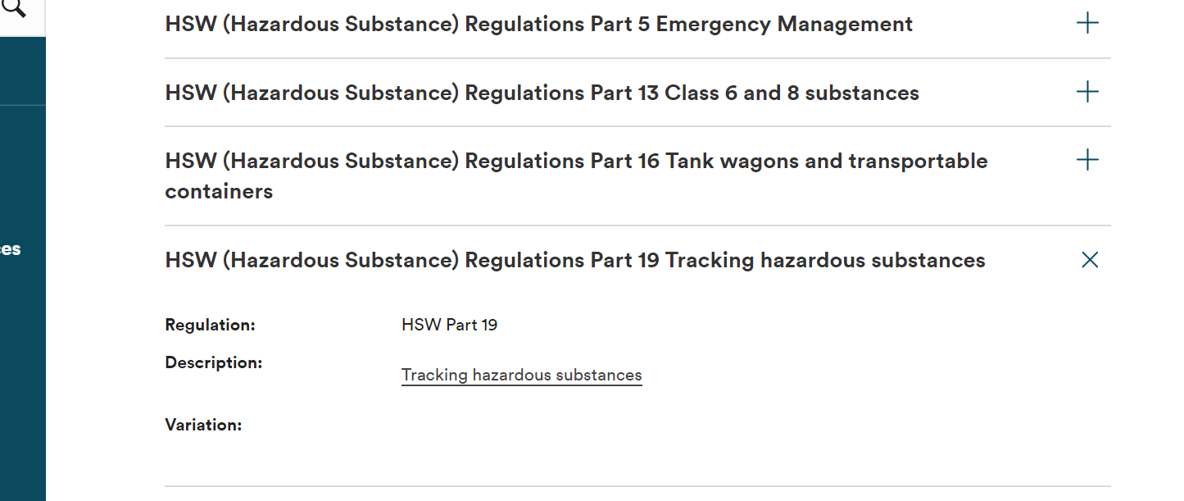
Part 19

-If you find Part 19 Tracking line: The chemical require special handling and record keeping unless the regulation states tracking is not necessary.
-If you do not find a tracking section: The chemical is exempt and does not require tracking.

